**7th grade** EXAM **Name:__________________________________**

1. **_________________________________**-the path of a moving point, it may be two-dimensional as a pencil mark on paper or three-dimensional as a wire or rope. There are five directions: horizontal, diagonal, vertical, zig-zag, and curved.
2. **Line b. Shape c. Form d. Texture e. Color f. Value g. Space**

Which direction of line is demonstrated in each image?

**Diagonal, vertical, horizontal, curved, or zig-zag**

1. 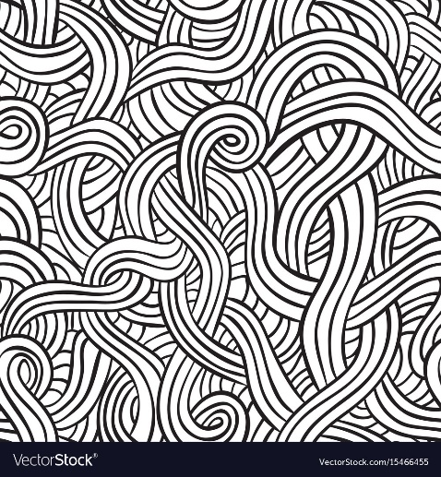 **3.** 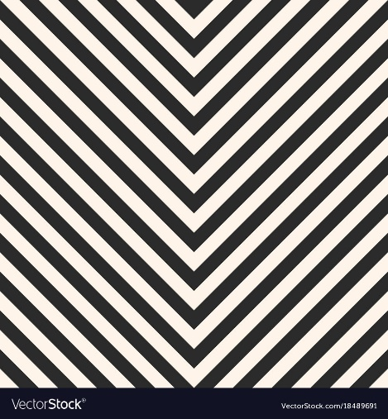

**___________________________ _________________________**

1.  **5.** 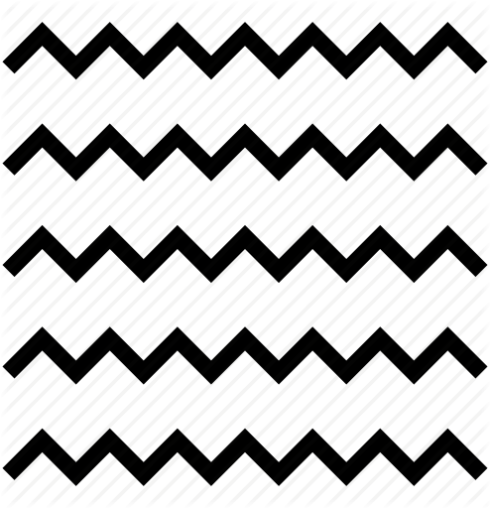

**_____________________________ _______________________________**

1. **____________________________**
2. **_________________________________-a two-dimensional closed area. It can be either geometric as a triangle or square or organic as with an irregular outline such as a leaf, cloud, or flower. It has two dimensions: length and width.**
3. **Line b. Shape c. Form d. Texture e. Color f. Value g. Space**
4. **Circles, squares, rectangles, and triangles. Shapes that can be easily measured.**
5. **Geometric shapes b. Organic shapes**
6. **Leaf, seashells, flowers. We see these shapes in nature which are free flowing, informal and irregular.**
7. **Geometric shapes b. Organic shapes**
8. **Which Picture demonstrates geometric shapes?**

**a. 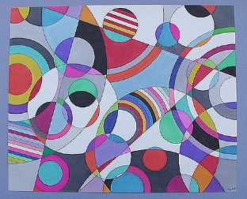 b.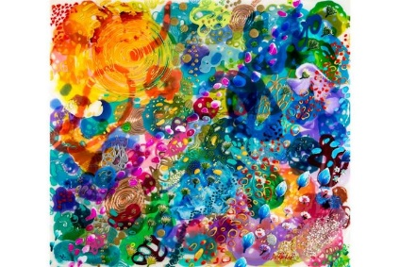 c.** 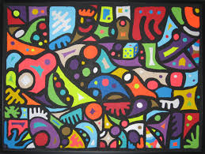

1. **Which Picture demonstrates organic shapes?**

**a.**  **b.**  **c.** 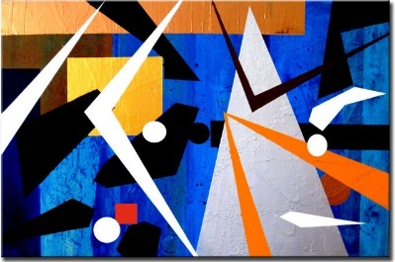

1. **Which picture demonstrates shapes and not forms?**
2. 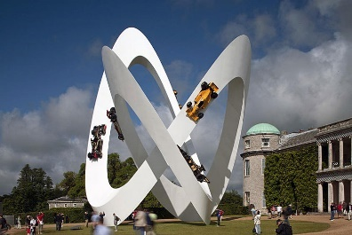 **b. 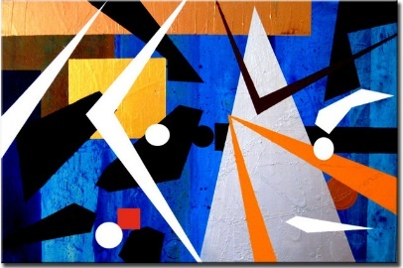 c.** 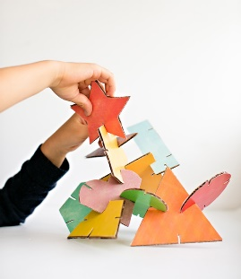

**7. _________________________________- a three-dimensional enclosed volume whether geometric as a pyramid, cube, sphere, or organic as a free-flowing form. You can hold a form; walk around a form and in some cases walk inside a form. In drawing or painting using value (shading) you can imply or give the illusion of a form. It has three dimensions: length, width, and height**

1. **Line b. Shape c. Form d. Texture e. Color f. Value g. Space**

**8. Which picture demonstrates forms and not shapes.?**

**a.** **b.**  **c.** 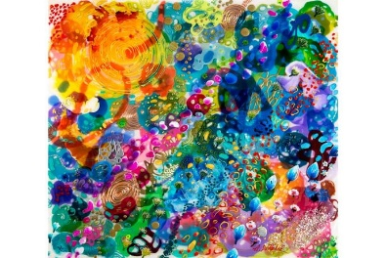

**1._________________________________- the surface quality of an object. The way something feels to the touch or how it may look as if touched.**

1. **Line b. Shape c. Form d. Texture e. Color f. Value g. Space**
2. **Actual texture of an object. A piece of pottery may have a rough texture so that it will look like it came from nature or a smooth texture to make it look like it is machine made.**
3. **Real Texture b. Implied Texture**
4. **a two-dimensional piece of art is made to look like a certain texture but in fact it is just a smooth piece of paper. Like a drawing of a tree trunk may look rough but in fact it is just a smooth piece of paper.**
5. **Real Texture b. Implied Texture**
6. **Which Picture is Implied Texture?**
7. 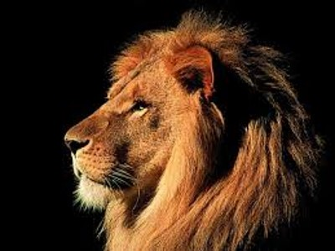 **b. 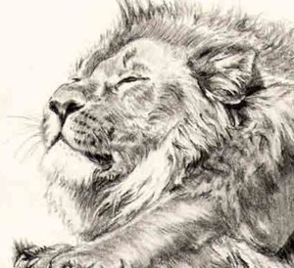 c.** 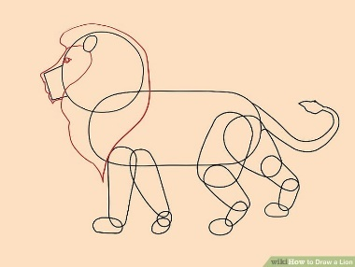
8. **Which Picture is Real Texture?**
9.  **b.**  **c.** 
10. **Which Picture does not show texture?**
11.  **b.**  **c.** 
12. _____________________________-the lightness and darkness of a color. Tints are light colors made by applying light pressure to a pencil or adding white. Shades are dark colors made by applying heavy pressure to a pencil or adding black, brown or the complement of the color. Gradation is when an artist smoothly or gradually goes from light to dark.
13. **Line b. Shape c. Form d. Texture e. Color f. Value g. Space**
14. **_________________ are light colors made by adding white or using light pressure on a pencil.**
15. **Tints b. Shades**
16. _____________________ are dark colors made by adding black or brown to a color or using heavy pressure on a pencil
17. **Tints b. Shades**
18. **___________________________________-** a hue of reflected light. The sensation of color is aroused in the brain by the response of the eyes to different wavelengths of light. A color has three parts: Hue (color name), Intensity (strength/purity), and value (lightness or darkness).
19. **Line b. Shape c. Form d. Texture e. Color f. Value g. Space**
20. **Red, yellow, and blue. These colors are pure colors and cannot be made by mixing other colors together.**
21. **Secondary colors b. Primary Colors c. Tertiary Colors d. Complementary e. Neutrals**
22. **Violet, green, and orange. Colors made by mixing two primary colors together.**
23. **Secondary colors b. Primary Colors c. Tertiary Colors d. Complementary e. Neutrals**
24. **Known as intermediate colors. These colors are made by mixing a primary with a secondary color. Example: red-violet, yellow-green or Blue-Violet.**
25. **Secondary colors b. Primary Colors c. Tertiary Colors d. Complementary e. Neutrals**
26. **Colors that are opposite each other on the color wheel. When placed next to each other they look bright and when mixed together they neutralize/darken each other.**
27. **Secondary colors b. Primary Colors c. Tertiary Colors d. Complementary e. Neutrals**
28. **A word used for black, white, brown and tints and shades of gray.**
29. **Secondary colors b. Primary Colors c. Tertiary Colors d. Complementary e. Neutrals**
30. **Two or more colors that appear next to each other on the color wheel.**
31. **Warm Colors b. Cool Colors c. Monochromatic Colors d. Analogous Colors**
32. **Sun Colors: Red, Yellow, and orange. They are located on one side of the color wheel.**
33. **Warm Colors b. Cool Colors c. Monochromatic Colors d. Analogous Colors**
34. **Ocean colors: Violet, green and Blue. They are located on one side of the color wheel.**
35. **Warm Colors b. Cool Colors c. Monochromatic Colors d. Analogous Colors**
36. **One color and its tints (light colors) and shades (dark colors)**
37. **Warm Colors b. Cool Colors c. Monochromatic Colors d. Analogous Colors**
38. **What Secondary Color should go in the #1 square?**

a. ORANGE b. GREEN c. VIOLET

1. **What Secondary Color should go in the #2 square?**
2. ORANGE b. GREEN c. VIOLET
3. **What Secondary Color should go in the #3 square?**
4. ORANGE b. GREEN c. VIOLET

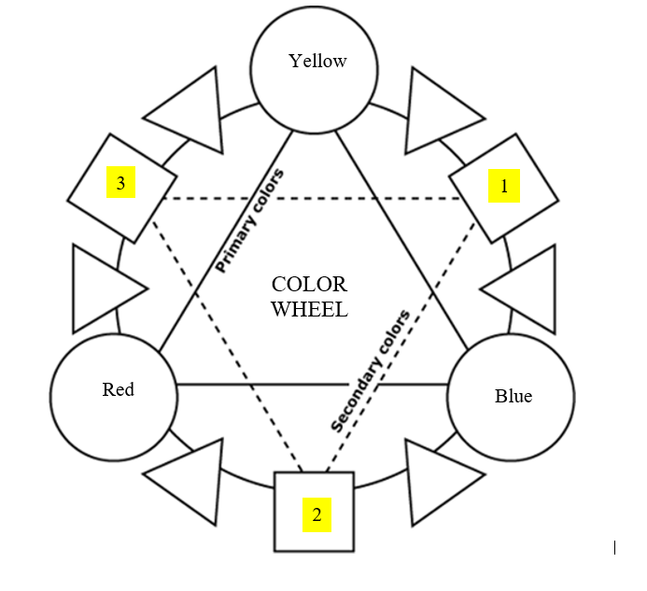

1. **What Tertiary Color should go in the #1 triangle?**

a. Red-Violet b. Red-Orange c. Yellow-Green

1. **What Tertiary Color should go in the #2 triangle?**
2. Red-Violet b. Red-Orange c. Yellow-Green
3. **What Tertiary Color should go in the #3 triangle?**
4. Yellow-Orange b. Blue-Green c. Blue-Violet
5. **What Tertiary Color should go in the #4 triangle?**
6. Yellow-Orange b. Blue-Green c. Blue-Violet
7. **What Tertiary Color should go in the #5 triangle?**
8. Yellow-Orange b. Blue-Green c. Yellow-Green
9. **What Tertiary Color should go in the #6 triangle?**
10. Yellow-Orange b. Blue-Green c. Yellow-Green

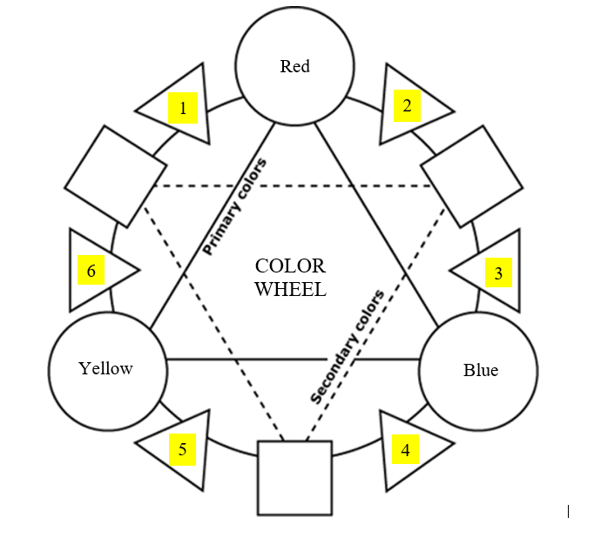

1. **__________________________**- areas in an artwork that indicate either positive or negative and/or the feeling of depth in a two-dimensional work of art. Positive space is the area occupied by an object. Negative spaces is the empty area surrounding an object.
2. **Line b. Shape c. Form d. Texture e. Color f. Value g. Space**
3. The method of showing depth by using the following techniques: Overlapping, Position, Size Variation, and Color. Faraway objects are small and less detailed. Up close objects are large and detailed.
4. **Fore-ground b. Middle ground c. Background d. Non-linear perspective**

**e. Linear Perspective f. horizon line g. vanishing point**

1. Area in an artwork that is closest to the viewer. The objects are large and detailed.
2. **Fore-ground b. Middle ground c. Background d. Non-linear perspective**

**e. Linear Perspective f. horizon line g. vanishing point**

1. Middle of an artwork or in between foreground and the background.

**a. Fore-ground b. Middle ground c. Background d. Non-linear perspective**

**e. Linear Perspective f. horizon line g. vanishing point**

1. Area in an artwork that is farthest away from the viewer. The objects are small and less detailed.

**a. Fore-ground b. Middle ground c. Background d. Non-linear perspective**

**e. Linear Perspective f. horizon line g. vanishing point**

1. A way of using a horizon line and vanishing point to make a flat piece of artwork have depth or seem three-dimensional.
2. **Fore-ground b. Middle ground c. Background d. Non-linear perspective**

**e. Linear Perspective f. horizon line g. vanishing point**

1. A horizontal line drawn where the earth meets the sky or at your eye level.
2. **Fore-ground b. Middle ground c. Background d. Non-linear perspective**

**e. Linear Perspective f. horizon line g. vanishing point**

1. A point on the Horizon Line where diagonal parallel lines meet.
2. **Fore-ground b. Middle ground c. Background d. Non-linear perspective**

**e. Linear Perspective f. horizon line g. vanishing point**

1. **__________________________________________**- The equalization of the elements of design. Elements are arranged to create a sense of stability. There are three kinds: **Symmetrical** (formal), **asymmetrical** (informal), and **radial** (round).

**a. Unity/Harmony b. Balance/Visual Weight c. Pattern d. Contrast**

**e. Variety f. Rhythm/Movement g. emphasis/focal point h. Proportion**

**2. Type of balance when both sides of the artwork are the same or almost the same**

1. **Radial Balance b. Symmetrical Balance c. Asymmetrical Balance**

**3.Type of balance when both sides of the artwork are NOT the same but the objects in the artwork take up the same amount space on both sides.**

1. **Radial Balance b. Symmetrical Balance c. Asymmetrical Balance**
2. **A type of balance based on a circle with its design extending. from center.**
3. **Radial Balance b. Symmetrical Balance c. Asymmetrical Balance**

**What type of balance is displayed in the picture?**

**Radial Balance, symmetrical balance or asymmetrical balance?**

**5.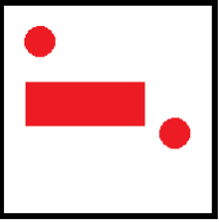 6.**  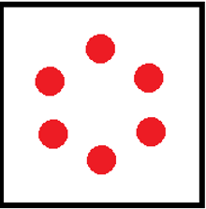 7. 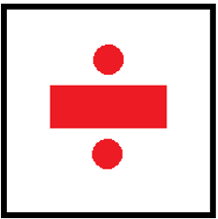

**_____________________ _________________________ ____________________**

**What type of balance is displayed in the picture?**

**Radial Balance, symmetrical balance or asymmetrical balance?**

1. 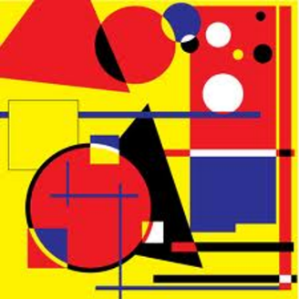 **9. 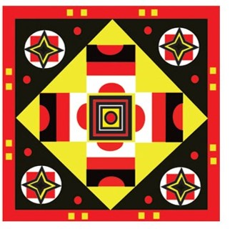 10.** 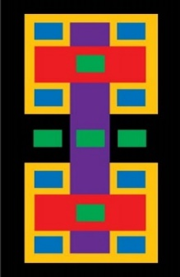

**___________________ ___________________ ____________________**

**11.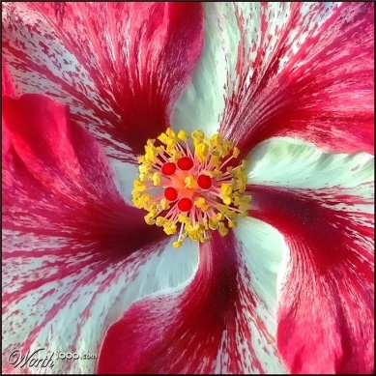 12.** 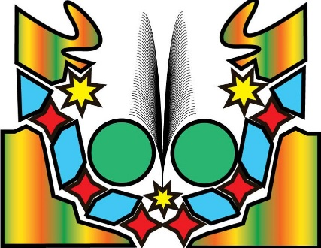 13. 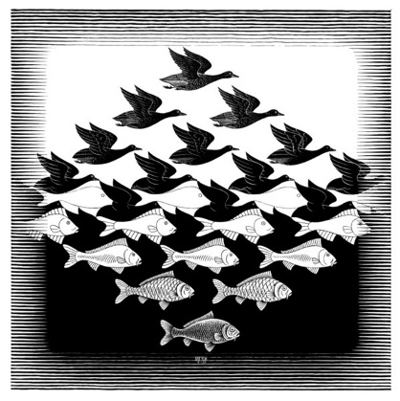

**___________________ ___________________ ____________________**

1. **____________________________________- the quality of seeming whole, complete, or harmonious. A successful composition is when all parts in the artwork work well together. It is the part of the artwork that is the same.**

**a. Unity/Harmony b. Balance/Visual Weight c. Pattern d. Contrast**

**e. Variety f. Rhythm/Movement g. emphasis/focal point h. Proportion**

1. **___________________________________________-**the use or combination of elements of art such as line, shape, or color to provide a complex relationship and interest in an artwork. It is the part of the artwork that is different.
2. **Unity/Harmony b. Balance/Visual Weight c. Pattern d. Contrast**

**e. Variety f. Rhythm/Movement g. emphasis/focal point h. Proportion**

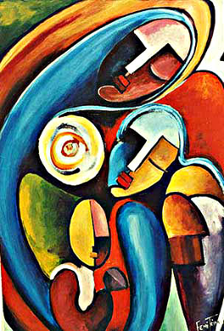

**5. What is the Unity in this artwork?**

a. The repeating oval faces.

b. All of the different colors in the artwork.

**6. What is the Variety in the artwork?**

a. The repeating oval faces.

b. All of the different colors in the artwork.

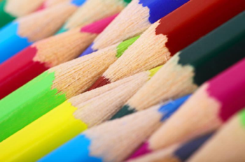

**3. What is the Unity in this artwork?**

a. They are all colored pencils

b. They are all different colors of colored pencils.

**4. What is the Variety in the artwork?**

a. They are all colored pencils

b. They are all different colors of colored pencils.

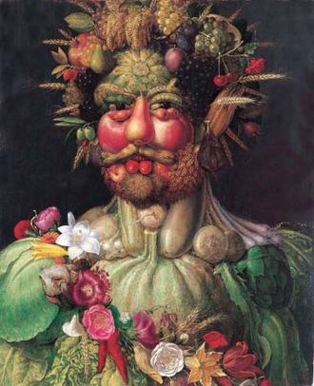

**7. What is the Unity in this artwork?**

a. The artwork is made of all fruits and vegetables

b. The fruits and vegetables are different colors, shapes, textures and sizes.

**8. What is the Variety in the artwork?**

a. The artwork is made of all fruits and vegetables

b. The fruits and vegetables are different colors, shapes, textures and sizes.

**1. ___________________________________-difference between two unlike things to create emphasis and interest.**

1. **Unity/Harmony b. Balance/Visual Weight c. Pattern d. Contrast**

**e. Variety f. Rhythm/Movement g. emphasis/focal point h. Proportion**

**What is the Contrast in each image? Size, Color or Texture?**

1. 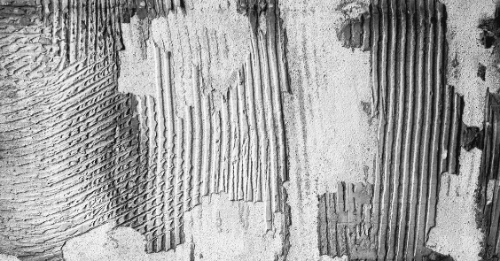 **3.** 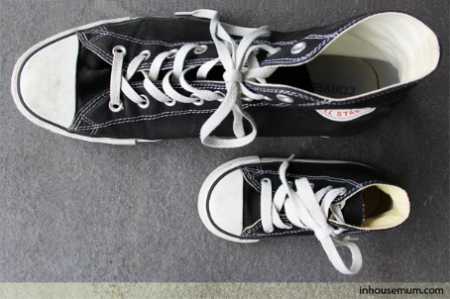

**________________________________ ______________________**

**4. 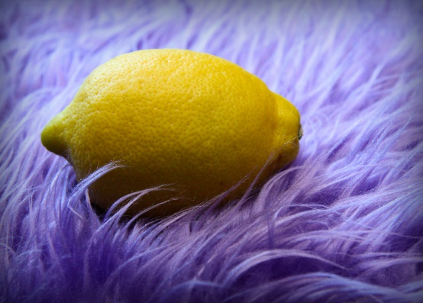 5.** 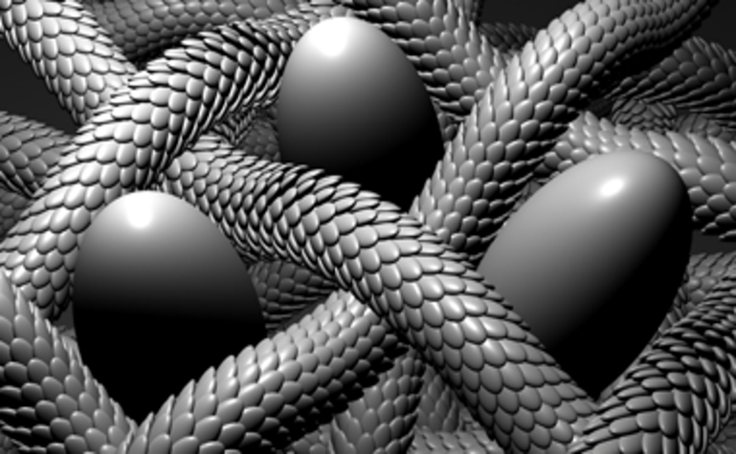

**_________________________________ ___________________________________**

1. 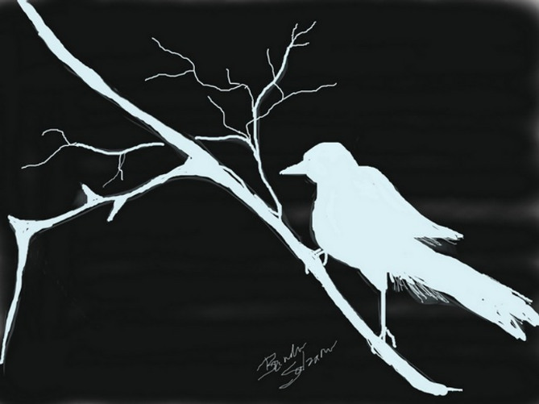 **7.** 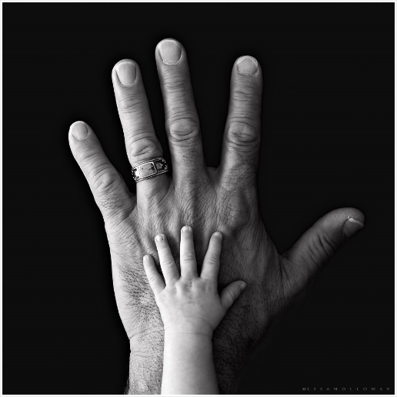

**__________________________________ ___________________________**

1. **__________________________________________-** relationship of parts in an artwork. A harmonious relationship of one part to another. It can be Standard or Altered
2. **Unity/Harmony b. Balance/Visual Weight c. Pattern d. Contrast**

**e. Variety f. Rhythm/Movement g. emphasis/focal point h. Proportion**

1. **_________________-Appropriate height, width and depth compared to the surroundings**
2. **Standard Proportion b. Altered Proportion**
3. **__________________-Abnormal height, width and depth compared to the surroundings.**
4. **Standard Proportion b. Altered Proportion**

**What type of proportion is seen in each picture? Standard Proportion or Altered Proportion**

1. 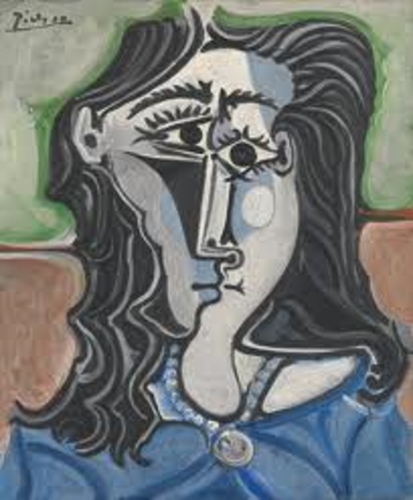 **5.** 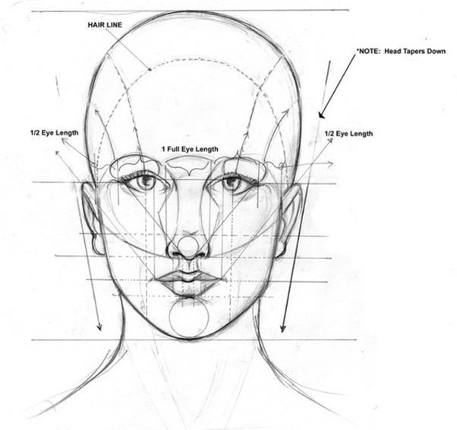

**_________________________ _________________________________**

1. 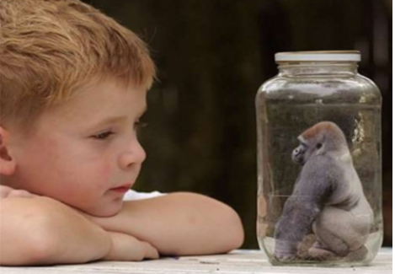 **7..** 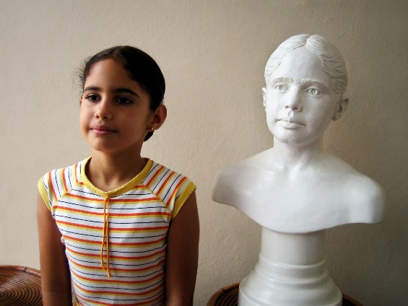

**___________________________________ ______________________________**

**1. ___________________________________- refers to arrangement or repetition of parts in a work of art to create a slow to fast movement of your eye through the work. Elements can also be arranged to create a visual tempo so that the viewers eyes moves across the artwork.**

1. **Unity/Harmony b. Balance/Visual Weight c. Pattern d. Contrast**

**e. Variety f. Rhythm/Movement g. emphasis/focal point h. Proportion**

1. 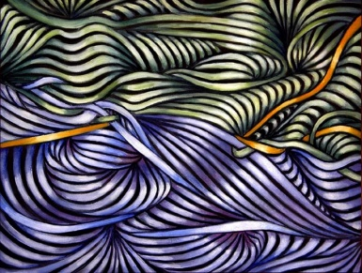

**2. What creates movement in this artwork?**

1. **The curve and repetition of the lines.**
2. **The colors in the artwork**
3. 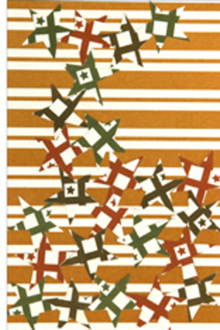

**3. What creates movement in this artwork?**

1. The repeating stars.
2. The colors in the artwork
3. **___________________________________________-**Importancegiven to certain objects or areas in an artwork. Size, color and placement of objects in an artwork can help create interest. It gives the eye a dominant or most important area on which to rest in the design.
4. **Unity/Harmony b. Balance/Visual Weight c. Pattern d. Contrast**

**e. Variety f. Rhythm/Movement g. emphasis/focal point h. Proportion**

1. 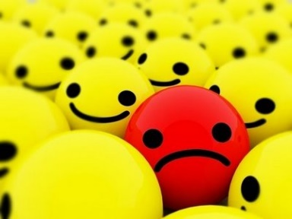
2. **What is the main emphasis in the artwork?**
3. All of the smiling faces.
4. The one frowning face.
5. 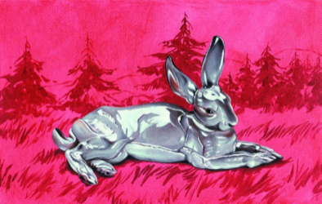
6. **What is the main emphasis in the artwork?**
7. The background of the artwork.
8. The large central rabbit in the artwork.
9. **__________________________________________**- Repeated colors, lines, shapes, forms or textures in an artwork. Also, a plan or model to be followed when making something. It can be organized in a grid, radial, or random order.

**a. Unity/Harmony b. Balance/Visual Weight c. Pattern d. Contrast**

**e. Variety f. Rhythm/Movement g. emphasis/focal point h. Proportion**

1. **_____________________________- Going back and forth between two different shapes, motifs, or colors in a grid or radial pattern.**
2. **Progressive pattern b. Alternating pattern c. Repeating pattern**
3. **_____________________________- Repeating a shape, motif, or color exactly the same way each time in a grid pattern.**
4. **Progressive pattern b. Alternating pattern c. Repeating pattern**
5. **_____________________________- the same motif changes progressively in some manner**
6. **Progressive pattern b. Alternating pattern c. Repeating pattern**

**How are the patterns arranged in each picture. In a Grid, Random order or radial order?**

1. 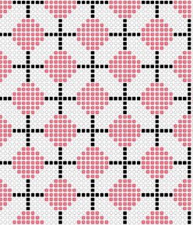 6. 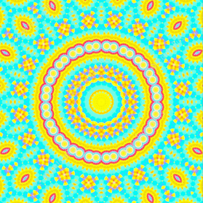 7. 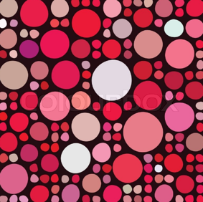

­­­­­­­­­­­­­­­­___________________ ___________________ __________________

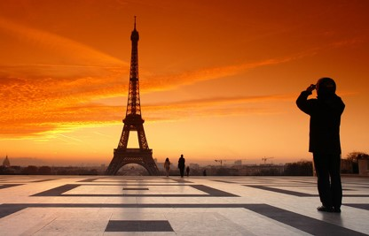

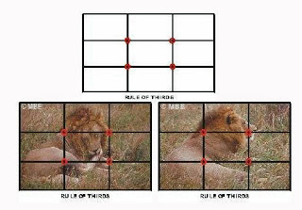

1. __________________________________the arrangement or placement of objects in an artwork to create an interesting, aesthetic and emotional response from the viewer.
2. Artwork b. Composition c. Picture

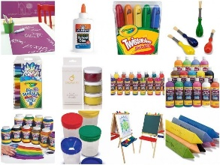

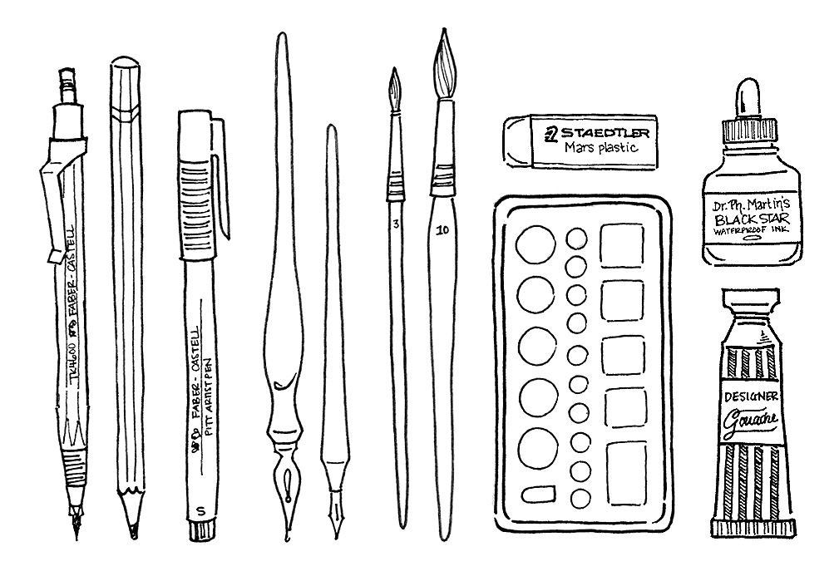

1. ________________________________/___________________________ materials used to create an artwork
2. Artwork b. Composition c. Media/medium

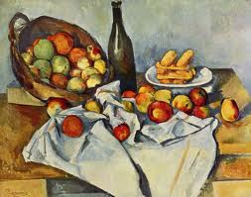

1. ______________________________The realistic, as perceived by the senses and natural [representation](http://www.artlex.com/ArtLex/Reh.html#anchor1012198) of people, places, and/or things in a work of [art](http://www.artlex.com/ArtLex/a/artquotations.html).
2. Realism b. Non-Objective c. Abstract

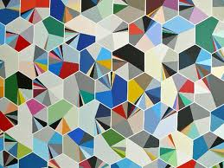

1. _____________________________[Artworks](http://www.artlex.com/ArtLex/Art.html#anchor1319429) having no recognizable [subject](http://www.artlex.com/ArtLex/Su.html#anchor3248455)  matter (not recognizable as such things as houses, trees, people, etc.) Also known as non-[representational](http://www.artlex.com/ArtLex/Reh.html#anchor1012198) art.
2. Realism b. Non-Objective c. Abstract

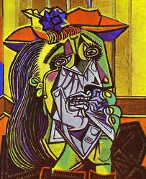

1. _______________________________Artwork that looks distorted or simplified into basic shapes. Artists select and then exaggerate or [simplify](http://www.artlex.com/ArtLex/Si.html#anchor1312158) the [forms](http://www.artlex.com/ArtLex/f/form.html) suggested by the world around them.
2. Realism b. Non-Objective c. Abstract

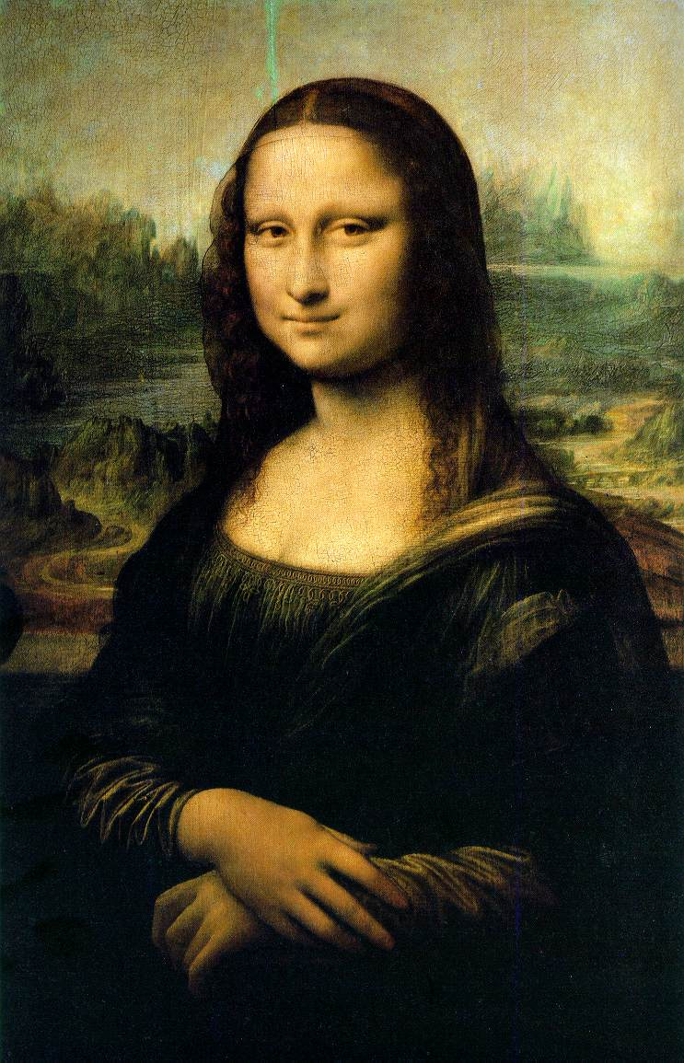

1. __________________________ a work of art created to show a person, animal, or group of people, usually focusing on the face.
2. Landscape b. Portrait c. Balance

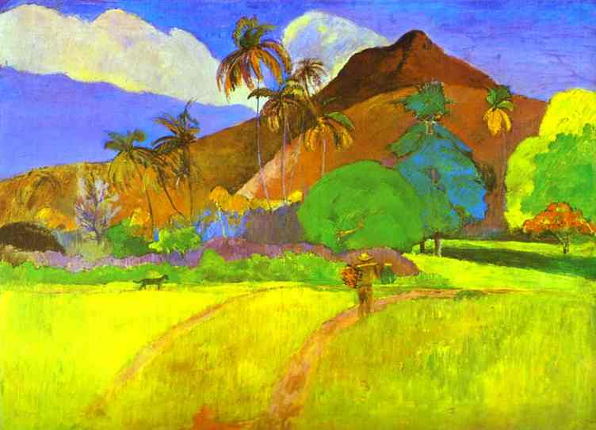

1. _______________________________ a drawing or painting that shows an outdoor scene or scenery, such as trees, lakes, mountains, and fields.
2. Landscape b. Portrait c. Balance