6th grade EXAM Name:__________________________________

- _________________________________-the path of a moving point, it may be two-dimensional as a pencil mark on paper or three-dimensional as a wire or rope. There are five directions of line: horizontal, diagonal, vertical, zig-zag, and curved.
- Line b. shape c. color d. form e. texture f. value g. space

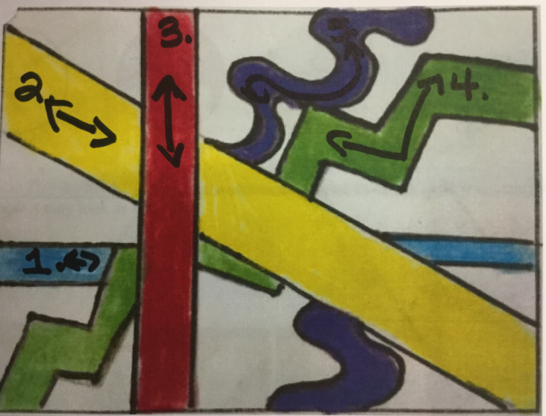
What direction of Line is the blue line #1?
- VERTICAL b. HORIZONTAL c. DIAGONAL d. CURVED
- ZIG-ZAG

What direction of Line is the Yellow line #2?
- VERTICAL b. HORIZONTAL c. DIAGONAL d. CURVED
- ZIG-ZAG

What direction of Line is the Red line#3?
- VERTICAL b. HORIZONTAL c. DIAGONAL d. CURVED
- ZIG-ZAG

What direction of Line is the Green line#4?
- VERTICAL b. HORIZONTAL c. DIAGONAL d. CURVED
- ZIG-ZAG

What direction of Line is the Violet line#5?
- VERTICAL b. HORIZONTAL c. DIAGONAL d. CURVED
- ZIG-ZAG

- _________________________________-a two-dimensional closed area. It can be either geometric as a triangle or square or organic as with an irregular outline such as a leaf, cloud, or flower. It has two dimensions: length and width.
a. Line b. shape c. color d. form e. texture f. value g. space

- Which image is a shape and not a form?

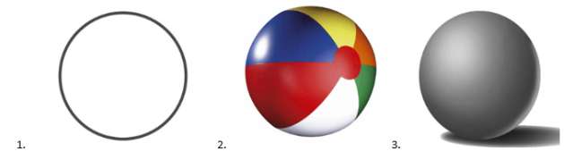

- _________________________________- the surface quality of an object. The way something feels to
the touch or how it may look as if touched.

- Line b. shape c. color d. form e. texture f. value g. space

- Which artwork does not show texture?
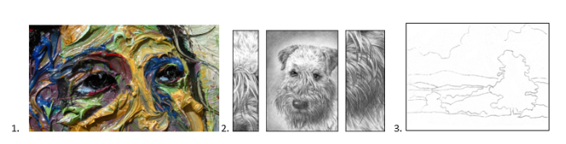

- _________________________________- a three-dimensional enclosed volume whether geometric as a pyramid, cube, sphere, or organic as a free-flowing form. You can hold a form; walk around a form and in some cases walk inside a form. In drawing or painting using value (shading) you can imply or give the illusion of a form. It has three dimensions: length, width, and height
a. Line b. shape c. color d. form e. texture f. value g. space

- Which image is a form and not a shape?

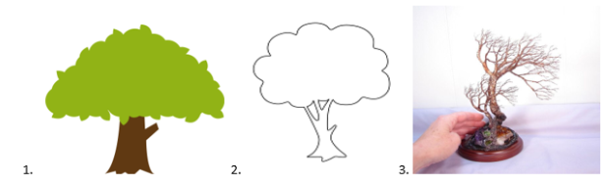

- ___________________________________- a hue of reflected light. The sensation of color is aroused in the brain by the response of the eyes to different wavelengths of light. A color has three parts: Hue (color name), Intensity (strength/purity), and value (lightness or darkness).
- Line b. shape c. color d. form e. texture f. Space g. value
- What are the three primary colors?
- Red, Yellow, and Blue
- Green, Orange, and Violet
- Black, Tan, white, brown, and gray
- Red-Violet, Red-Orange, Yellow-Green, Yellow-Orange, Blue-Green, and Blue-Violet

- What are the three Secondary colors?
- Red, Yellow, and Blue
- Green, Orange, and Violet
- Black, Tan, white, brown, and gray
- Red-Violet, Red-Orange, Yellow-Green, Yellow-Orange, Blue-Green, and Blue-Violet

- What are tertiary colors?
- Red, Yellow, and Blue
- Green, Orange, and Violet
- Black, Tan, white, brown, and gray
- Red-Violet, Red-Orange, Yellow-Green, Yellow-Orange, Blue-Green, and Blue-Violet

- What are neutrals colors?
- Red, Yellow, and Blue
- Green, Orange, and Violet
- Black, Tan, white, brown, and gray
- Red-Violet, Red-Orange, Yellow-Green, Yellow-Orange, Blue-Green, and Blue-Violet

- Which set of colors are represented in the picture? (brown, black, gray and white)
- Primary color b. Secondary colors c. Complementary colors d. Tertiary colors e. Neutrals
- Which set of colors are represented in the picture?Green/Red, Orange/Blue, Violet/Yellow
- Primary color b. Secondary colors c. Complementary colors d. Tertiary colors e. Neutrals
8. Which set of colors are represented in the picture?(red, yellow, and blue)
- Primary color b. Secondary colors c. Complementary colors d. Tertiary colors e. Neutrals
- Which set of colors are represented in the picture?(green, orange, and violet)
- Primary color b. Secondary colors c. Complementary colors d. Tertiary colors e. Neutrals

10.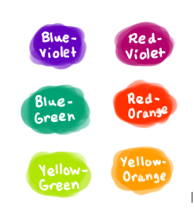 Which set of colors are represented in the picture?
(red-violet, blue-green, yellow-green, red-orange, yellow-orange, blue-Violet.
- Primary color b. Secondary colors c. Complementary colors d. Tertiary colors e. Neutrals

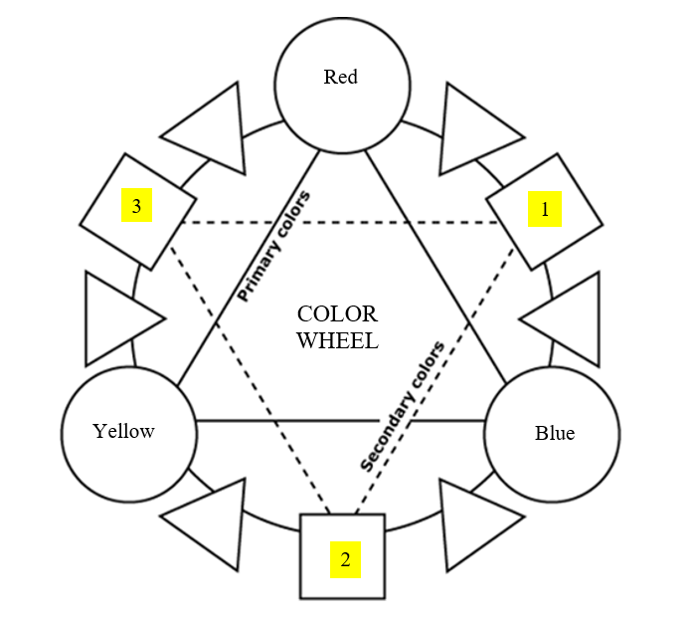
- What Tertiary Color should go in the #1 triangle?
a. Red-Violet b. Red-Orange c. Yellow-Green

- What Tertiary Color should go in the #2 triangle?
- Red-Violet b. Red-Orange c. Yellow-Green

- What Tertiary Color should go in the #3 triangle?
- Yellow-Orange b. Blue-Green c. Blue-Violet

- What Tertiary Color should go in the #4 triangle?
- Yellow-Orange b. Blue-Green c. Blue-Violet

- What Tertiary Color should go in the #5 triangle?
- Yellow-Orange b. Blue-Green c. Yellow-Green

- What Tertiary Color should go in the #6 triangle?
- Yellow-Orange b. Blue-Green c. Yellow-Green

- What Secondary Color should go in the #1 square?
a. ORANGE b. GREEN c. VIOLET

- What Secondary Color should go in the #2 square?
- ORANGE b. GREEN c. VIOLET

- What Secondary Color should go in the #3 square?
- ORANGE b. GREEN c. VIOLET

- ORANGE b. GREEN c. VIOLET

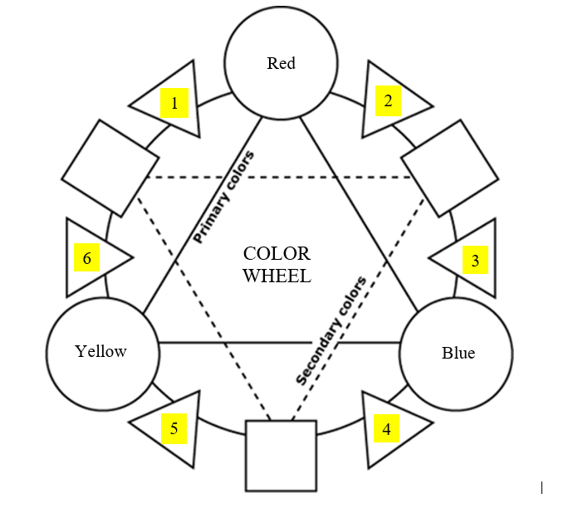

- _____________________________-the lightness and darkness of a color. Tints are light colors made by applying light pressure to a pencil or adding white. Shades are dark colors made by applying heavy pressure to a pencil or adding black, brown or the complement of the color. Gradation is when an artist smoothly or gradually goes from light to dark.

- Line b. shape c. color d. form e. texture f. value g. space

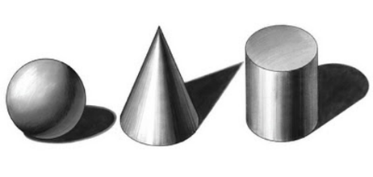
- Where light hits an object and creates light areas. A. Highlights B. Shadows C. Cast shadow

- Dark areas of your artwork where light does not hit. A. Highlights B. Shadows C. Cast shadow

- A shadow (shades) created when a light hits an object and it cast a shadow away from the light.
A. Highlights B. Shadows C. Cast shadow

- __________________________- areas in an artwork that indicate either positive or negative and/or the feeling of depth in a two-dimensional work of art. Positive space is the area occupied by an object. Negative space is the empty area surrounding an object.

- Line b. shape c. color d. form e. texture f. value g. space

- ______________ Perspective is the method of showing depth by using the following techniques: Overlapping, Position, Size Variation, and Color. Faraway objects are small and less detailed. Up close objects are large and detailed.
- Linear Perspective b. Non-Linear Perspective c. Foreground
d. Middle-Ground e. Background f. Horizon Line g. Vanishing Point

- Area in an artwork that is closest to the viewer. The objects are large and detailed.
a. Linear Perspective b. Non-Linear Perspective c. Foreground
d. Middle-Ground e. Background f. Horizon Line g. Vanishing Point

- The middle of an artwork or in between foreground and the background.
- Linear Perspective b. Non-Linear Perspective c. Foreground
d. Middle-Ground e. Background f. Horizon Line g. Vanishing Point

- Area in artwork that is farthest away from the viewer. The objects are small and less detailed.
- Linear Perspective b. Non-Linear Perspective c. Foreground
d. Middle-Ground e. Background f. Horizon Line g. Vanishing Point

- _________________Perspective is a way of using a horizon line and vanishing point to make a flat piece of artwork have depth or seem three-dimensional
- Linear Perspective b. Non-Linear Perspective c. Foreground
d. Middle-Ground e. Background f. Horizon Line g. Vanishing Point

- A Horizontal line drawn where the earth meets the sky or at your eye level.
- Linear Perspective b. Non-Linear Perspective c. Foreground
d. Middle-Ground e. Background f. Horizon Line g. Vanishing Point

- A point on the Horizon Line where diagonal parallel lines meet.
- Linear Perspective b. Non-Linear Perspective c. Foreground
d. Middle-Ground e. Background f. Horizon Line g. Vanishing Point

What type of perspective is used to create the artwork in #9 and # 10? Linear Perspective or Non-Linear Perspective?

- 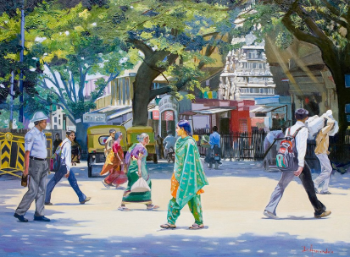 10. 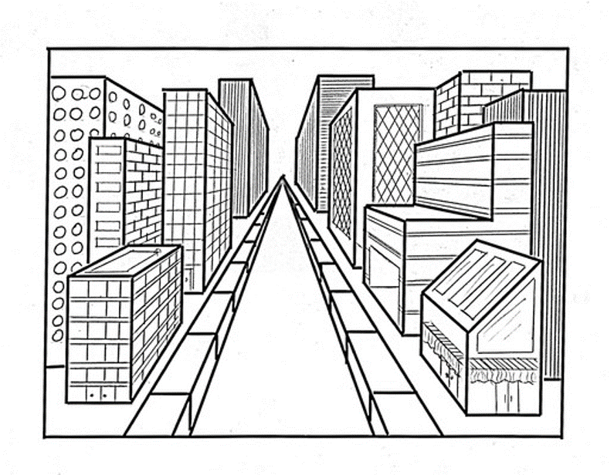
_______________________ _______________________

- __________________________________________- Repeated colors, lines, shapes, forms or textures in an artwork. Also, a plan or model to be followed when making something. It can be organized in a grid, radial, or random order.
a. Unity/Harmony b. Balance/Visual Weight c. Pattern d. Contrast
e. Variety f. Rhythm/Movement g. emphasis/focal point h. Proportion

- Going back and forth between two different shapes, motifs, or colors in a grid or radial pattern.
- Alternating pattern b. repeating pattern c. progressive pattern

- Repeating a shape, motif, or color exactly the same way each time in a grid pattern.
- Alternating pattern b. repeating pattern c. progressive pattern

- the same motif changes progressively in some manner
- Alternating pattern b. repeating pattern c. progressive pattern

- ___________________________________________-the use or combination of elements of art such as line, shape, or color to provide a complex relationship and interest in an artwork. It is parts of the artwork that are different.
a. EMPHASIS/FOCAL POINT b. UNITY/HARMONY c. PROPORTION
d. PATTERN e. CONTRAST f. BALANCE/VISUAL WEIGHT
g. VARIETY h. RHYTHM/MOVEMENT

6. What is the Variety in the picture?
- They are all people
- They are different sizes, colors, and shapes.

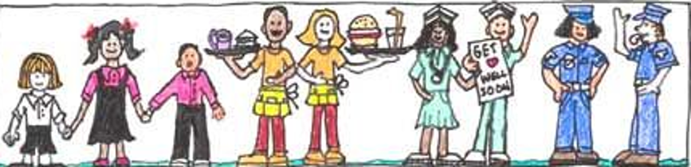

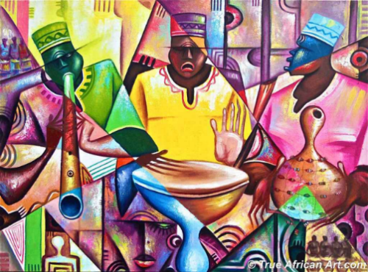
7.What is the Variety of the picture?
- They are all musicians
- They are different sizes, colors, and shapes.

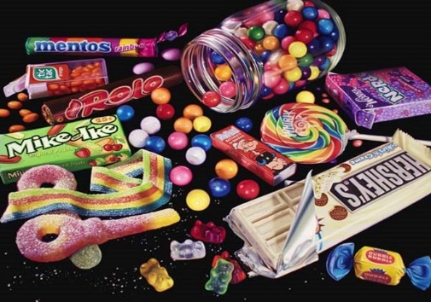
8. What is the Variety of the picture?
- The objects are all types of candy
- They are different sizes, colors, and shapes

- ___________________________________________- refers to arrangement or repetition of parts in a work of art to create a slow to fast movement of your eye through the work. Elements can also be arranged to create a visual tempo so that the viewers eyes moves across the artwork.

a. Unity/Harmony b. Balance/Visual Weight c. Pattern d. Contrast
e. Variety f. Rhythm/Movement g. emphasis/focal point h. Proportion

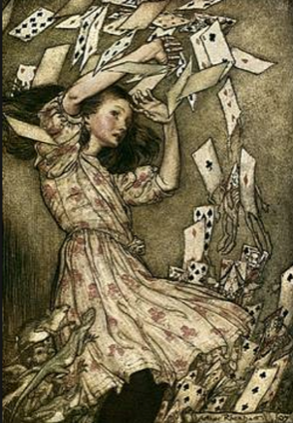
- What is creating Rhythm and Movement in the picture?
- The mouse and lizard in the lower left corner.
- The girl’s hair.
- The deck of cards repeating from the top to the bottom of the artwork.

3.__________________________________________-the quality of seeming whole, complete, or harmonious. A successful composition is when all parts in the artwork work well together. It is the parts of an artwork that are the same.
a. Unity/Harmony b. Balance/Visual Weight c. Pattern d. Contrast
e. Variety f. Rhythm/Movement g. emphasis/focal point h. Proportion

4. What is the Unity in the picture?
- They are all people
- They are different sizes, colors, and shapes.

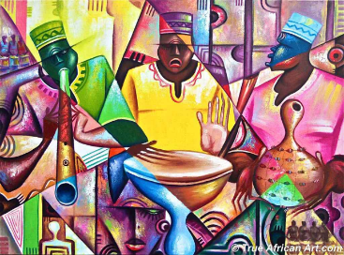
5. What is the Unity of the picture?
- They are all musicians
- They are different sizes, colors, and shapes.

6. What is the Unity of the picture?
- The objects are all types of candy
- They are different sizes, colors, and shapes

- __________________________________________- The equalization of the elements of design. Elements are arranged to create a sense of stability. There are three kinds: Symmetrical (formal), asymmetrical (informal), and radial (round).
a. Unity/Harmony b. Balance/Visual Weight c. Pattern d. Contrast
e. Variety f. Rhythm/Movement g. emphasis/focal point h. Proportion

What type of balance is seen in each picture? Is it radial, symmetrical or asymmetrical balance?
- 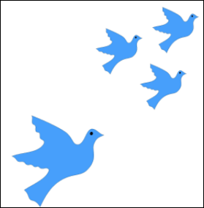 3. 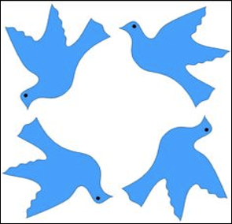 4. 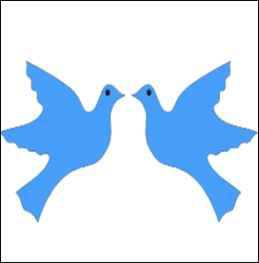
_________________ ______________________ ______________________

5. 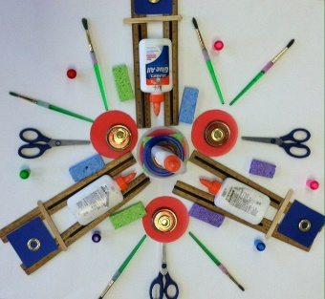 6 .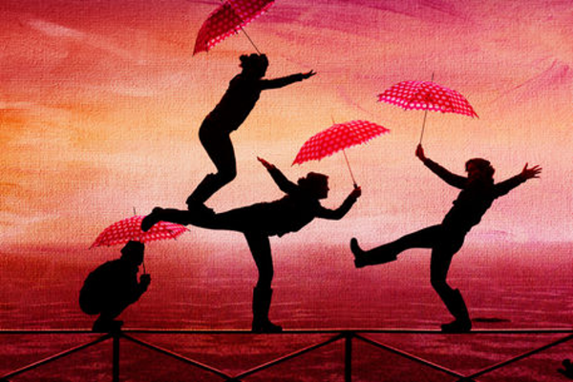 7. 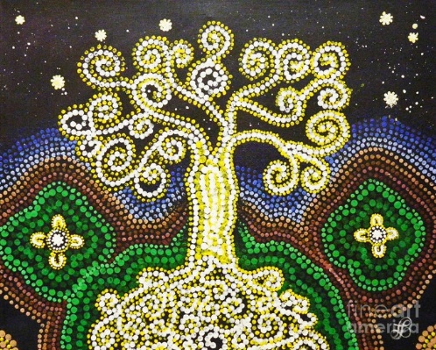

_____________________ ______________________________ _________________________

- __________________________________________- relationship of parts in an artwork. A harmonious relationship of one part to another. It can be Standard (appropriate height, width and depth compared to the surroundings) or Altered (Abnormal height, width and depth compared to the surroundings.)
a. Unity/Harmony b. Balance/Visual Weight c. Pattern d. Contrast
e. Variety f. Rhythm/Movement g. emphasis/focal point h. Proportion

What type of proportion is seen each picture? Is it Standard Proportion or Altered Proportion?
- 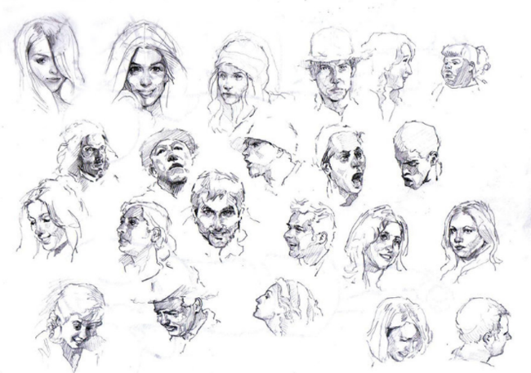 10. 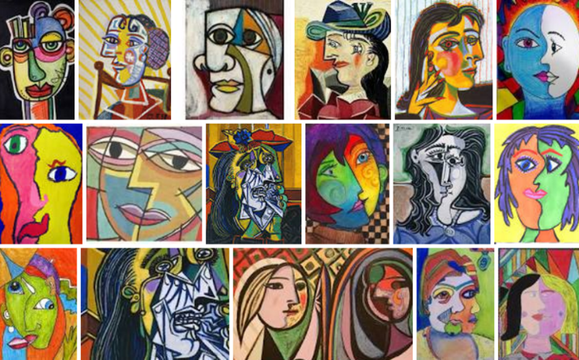

___________________________________ _____________________________________

- __________________________________________-difference between two unlike things to create emphasis and interest.
a. Unity/Harmony b. Balance/Visual Weight c. Pattern d. Contrast
e. Variety f. Rhythm/Movement g. emphasis/focal point h. Proportion

What is Contrasting in each picture? Texture, color or size?

- 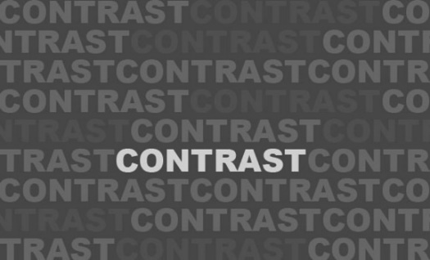 3. 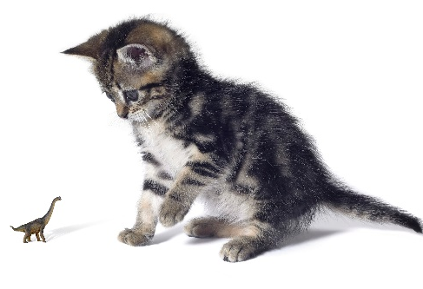 4. 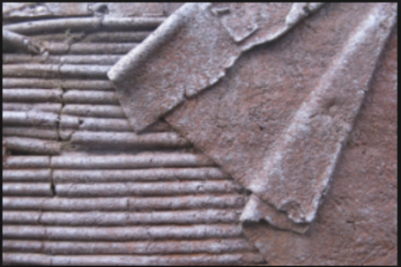

____________________________ _______________ _____________________

- ___________________________________________-Importance given to certain objects or areas in an artwork. Size, color and placement of objects in an artwork can help create interest. It gives the eye a dominant or most important area on which to rest in the design.
a. Unity/harmony b. Balance/Visual Weight c. Pattern d. Contrast
e. Variety f. Rhythm/Movement g. emphasis/focal point h. Proportion

- 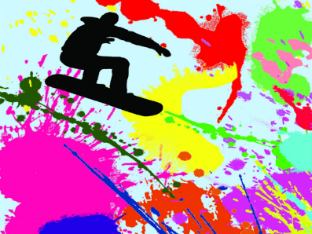
6. What is the main Emphasis/Focal Point in the Picture?
a. The paint Splatters.
b. The snow boarder.
7. What is the main Emphasis/Focal Point in the Picture?
a. All of the squares.
b. The large red square in the middle.
- 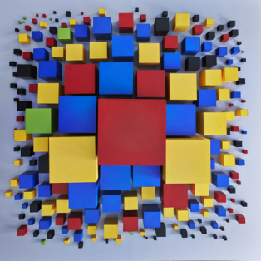
- 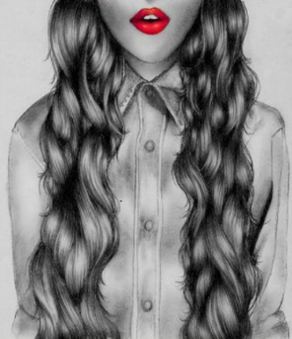
8. What is the main Emphasis/Focal Point in the Picture?
a. The girl’s shirt
b. the girl’s lips.

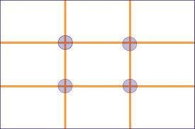
- _________________-the arrangement or placement of objects in an artwork to create an interesting, aesthetic and emotional response from the viewer.

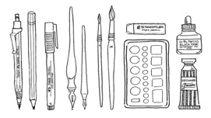
- _________________-materials used to create an artwork. Materials such as: markers, crayons, graphite pencils, pastels, colored pencils, acrylic paint, tempera paint, water color, oil paint, clay, metal, mixed media, collages, papier-mâché, wire, etc...

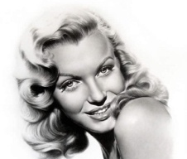
- ________________-the realistic, as perceived by the senses and natural representation of people, places, and/or things in a work of art.

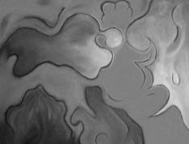
- _________________- artworks having no recognizable subject matter (not recognizable as such things as houses, trees, people, etc.) Also known as non-representational art.

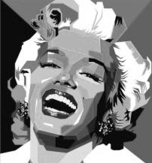
- _________________- artwork that looks distorted or simplified into basic shapes. Artists select and then exaggerate or simplify the forms suggested by the world around them.

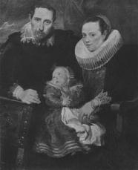
- __________________-a work of art created to show a person, animal, or group of people, usually focusing on the face.

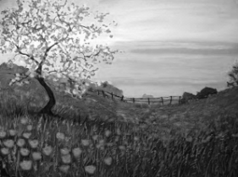
- ______________-a drawing or painting that shows an outdoor scene or scenery, such as trees, lakes, mountains, and fields.

Word Bank
Abstract Realism Non-Objective Landscape
Media/Medium Portrait Composition

